DMBS LAB ASSIGNMENT -4 BY 23BIT205

1. List total deposit from deposit.



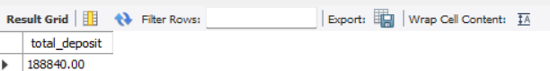

2) List total loan from karolbagh branch



Output

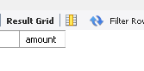

3) Give maximum loan from branch vrce.



OUTPUT

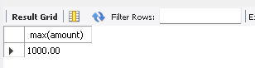

4)Count total number of customer



OUTPUT

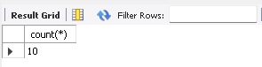

5) Count total number of customer’s cities.



Output

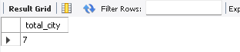

6) Create table supplier from employee with all the columns.



Output

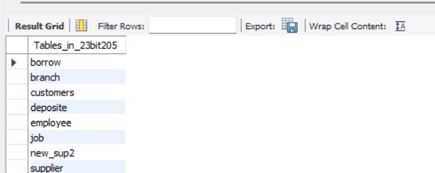

7) Create table sup1 from employee with first two columns.



Output

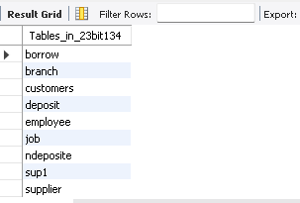

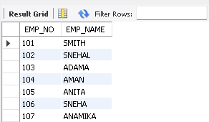

8) Create table sup2 from employee with no data



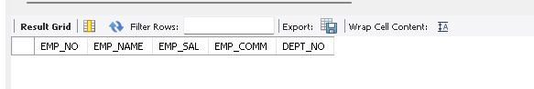

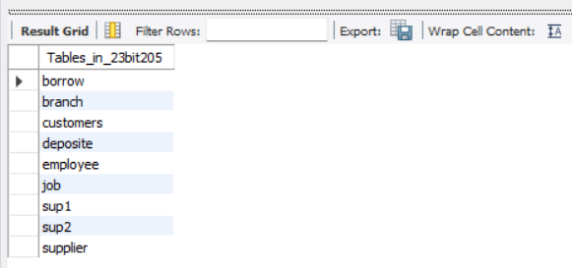

9)Insert the data into sup2 from employee whose second character should be ‘n’ and string should be 5 characters long in employee name field.

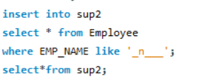

Output

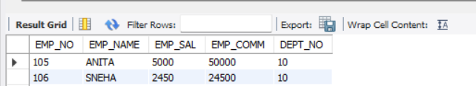

10)Delete all the rows from sup1.

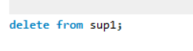

11)Delete the detail of supplier whose sup_no is 103.



Output

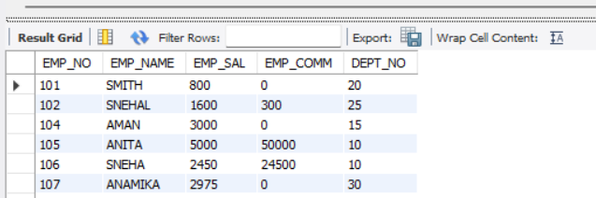

12)Rename the table sup2.



Output

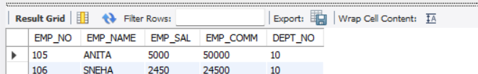

13)Destroy table sup1 with all the data.



Output

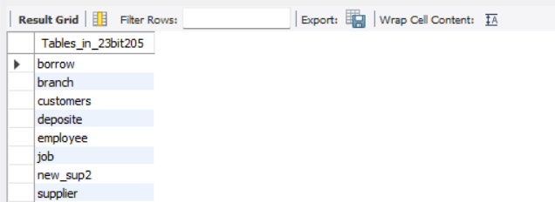

14)Update the value dept_no to 10 where second character of

emp. name is ‘m’.

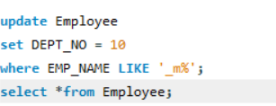

Output

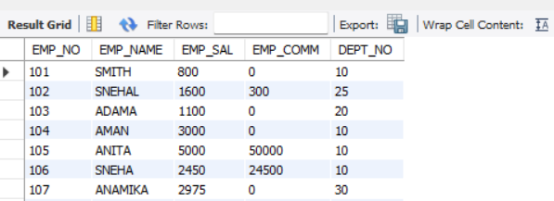

15)Update the value of employee name whose employee number is 103.

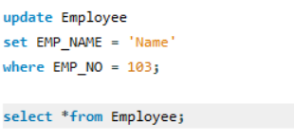

Output

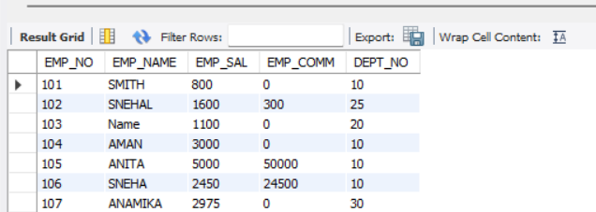

16)Add one column phone to employee with size of column is 10.



Output

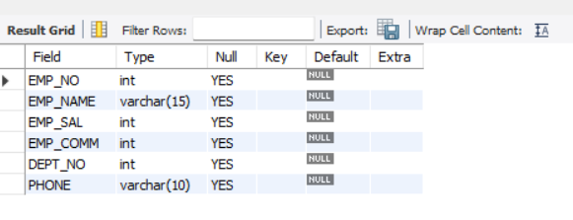

17)Modify the column emp_name to hold maximum of 30 characters.



Output

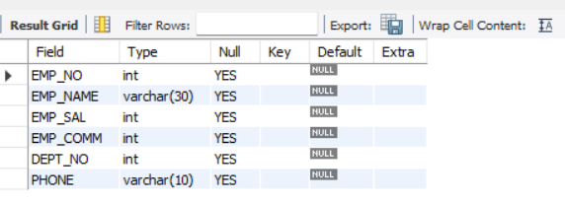

18)Count the total no as well as distinct rows in dept_no column with a condition of salary greater than 1000 of employee.



Output

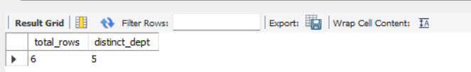

19)Display the detail of all employees in ascending order, descending order of their name and no.

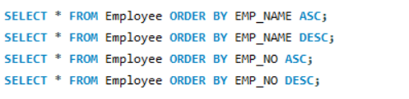

Output

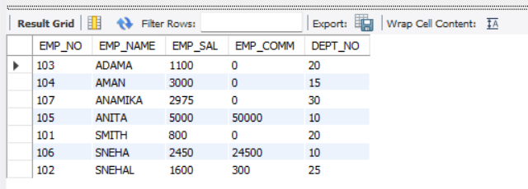

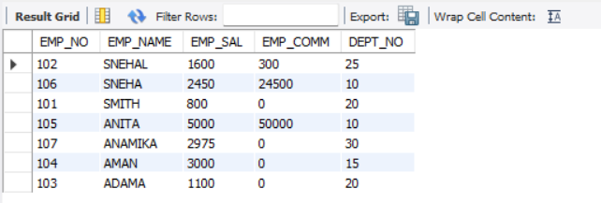

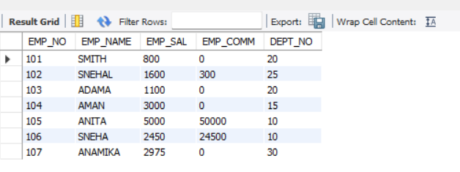

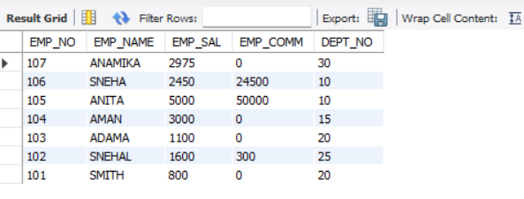

20)Display the dept_no in ascending order and accordingly display emp_comm in descending order.



Output

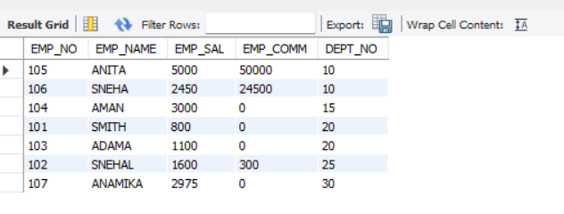

21)Update the value of emp_comm to 500 where dept_no is 20.

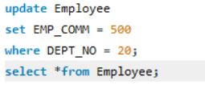

Output

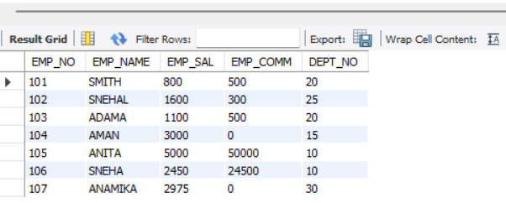

22)Display the emp_comm in ascending order with null value first and accordingly sort employee salary in descending order.



Output

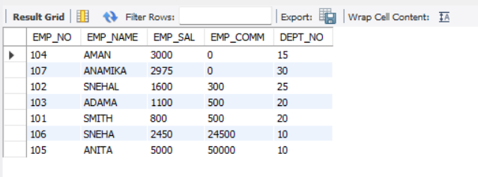

23)Display the emp_comm in ascending order with null value last and accordingly sort emp_no in descending order.



